* *[Home](http://www.njhcn.org/" \o "Home)*
* *>*
* [*Grantee Blog 2020*](http://www.njhcn.org/category/grantee-blog-2020/)
* *>*
* ***Vauxhall Community Garden’s Youth Participates In Union’s Farmers Market***

**Vauxhall Community Garden’s Youth Participates In Union’s Farmers Market**

October 6, 2020

Grantee: [Golden Rule Lodge No 24](http://www.njhcn.org/grantees2020/golden-rule-lodge-no-24/)

Strategy: [Healthy Eating Audit HE#1](http://www.njhcn.org/strategies2020/healthy1/)

City: [Union](http://www.njhcn.org/cities2020/union/)

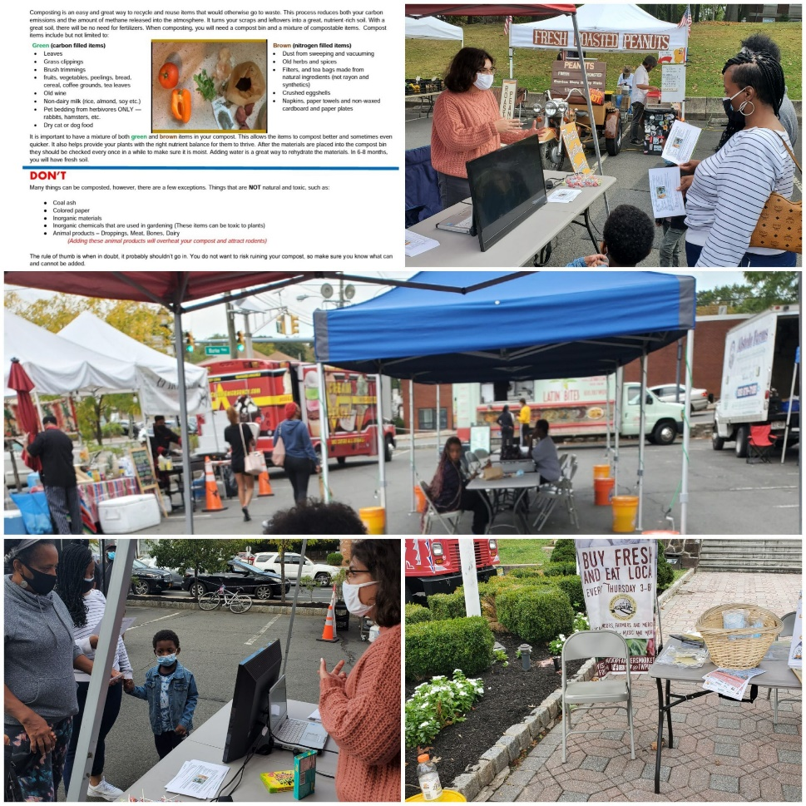

Vauxhall Community Youth participated in the Township of Unions Farmer Market, a booth was setup for the youth to pass out information as well answer questions to the Community on the benefits of composting. During the presentation a Video on why you should compost and how to compost was continuously showed by the participants.

Vauxhall Community Garden appreciates Youth participation in our endeavors to educate the community on Healthy eating and the benefits of Compost, which can improve soil quality for healthier plants, add nutrients to slowly feed plants, saves money on fertilizers, helps soil hold more water, therefore your plants need less water, Composting also helps reduce pests and disease, assists in balancing soil PH and finally improves soil structure.

Vauxhall Community Garden looks forward to more participation from our youth as we continue to educate our community on Healthy Eating.

“This work is supported by funding from Atlantic Health System as part of the New Jersey Healthy Communities Network.”

ABOUT THE GRANTEE

[**Golden Rule Lodge No 24**](http://www.njhcn.org/grantees2020/golden-rule-lodge-no-24/)

The members of Golden Rule Lodge No 24 and Golden Rule Chapter No 50 are a community based organization; we worked within the Vauxhall Community by providing and assisting with healthy eating and living. In our Community garden we grow and donate fresh vegetables to the Vauxhall residents and surrounding communities, it enables us to assist the community in maintaining a healthy lifestyle.

http://www.njhcn.org/grantees2020/golden-rule-lodge-no-24/